AI- Driven Smart Security Surveillance: Enhanced YOLO Model for Optimal Security
Chirag Aggarwal¹, Shashwat Jain² and Ankit Raj³
¹ School of Computer Science Engineering and Technology, Bennett University, Greater Noida, Uttar Pradesh, India
chiragaggarwal5k@gmail.com
² School of Computer Science Engineering and Technology, Bennett University, Greater Noida, Uttar Pradesh, India
shashwatjain2k3@gmail.com
³ School of Computer Science Engineering and Technology, Bennett University, Greater Noida, Uttar Pradesh, India
ankitraj46767@gmail.com
Abstract. This study explores the application of advanced AI techniques in security systems, focusing on the YOLO object detection framework. We investigate how this technology can create more intelligent and reliable residential surveillance. Our research demonstrates that AI-powered systems can significantly enhance threat detection while minimizing false alarms. By training YOLO models on a diverse dataset reflecting various environments, we achieved high accuracy in identifying potential threats. Key findings include real-time processing capabilities and low false positive rates for threat objects. These results suggest AI integration can substantially improve surveillance effectiveness, potentially reducing response times to genuine threats and decreasing unnecessary alarms. However, our study also highlights important considerations for real-world implementation, including privacy concerns and system adaptability.
Keywords: Security, AI Surveillance, YOLO, Object Detection, Non-Maximal Suppression, False Positive Reduction
- Introduction
Security surveillance has become a paramount concern in contemporary society, driven by increasing crime rates and the need for effective surveillance solutions. Unless it can monitor your home or workspace for potential threats and alert someone when it detects such threats, a security system isn't very reliable [1]. Traditional security systems, where human resources are dedicated to observing cameras 24 hours a day, often fall short in providing real-time monitoring and accurate threat detection, making it very expensive. An automated system that monitors events in different locations using surveillance cameras is therefore essential [2].
Motion and object detection are fundamentals for almost every visual surveillance system. Motion detection aims at segmenting regions corresponding to moving objects from the rest of an image [3]. Among these emerging technologies, the YOLO (You Only Look Once) object detection framework has emerged as a promising tool for enhancing security systems. YOLO's single-shot/stage architecture makes it particularly well-suited for real-time applications, enabling rapid processing of video feeds and accurate detection of objects of interest. Various other models use a similar architecture such as Single Shot Detector (SSD), Deconvolution Single Shot Detector (DSSD), RetinaNet, M2Det, RefineDet++, etc. However, YOLO stands out for its simplicity, efficiency, and ease of implementation, making it an attractive choice for security surveillance applications [4].
Just like how humans take a glance at an image and are instantly able to detect any anomalies in it, fast and accurate algorithms would allow computers to do the same [5]. The integration of YOLO-based object detection systems into surveillance system holds significant promise in this regard. These artificial intelligence-based surveillance solutions can be beneficial to homeowners since they can differentiate between a possible threat, for instance, a weapon or a suspicious person when compared with other objects available at home, and depending on the situation, send real-time notifications to the house owners. Furthermore, the possibility to work with video stream in real time makes it possible to respond to the situations as soon as they occur, which can help to prevent or lessen the consequences of incidents and increase the efficiency of safety systems.
In this research study, we aim to investigate the application of the various versions of YOLO object detection algorithm by the Ultralytics Team, in the context of military security systems. By evaluating the performance of various YOLO model configurations, we seek to identify the optimal balance between detection accuracy, processing speed, and computational requirements, ensuring that the technology can be effectively deployed in residential environments. Additionally, we explore the development of a custom dataset tailored to military security scenarios, addressing the unique challenges posed by diverse settings and the need to distinguish between threat and non-threat objects.
By adopting this systematic procedure, we aim at unveiling the enormous possibility of using AI for the improvement of security, reduction of insecurity incidences and ultimately meeting the privacy challenge. Through the proposed model using the YOLO framework, data curation and modeling techniques that have been presented in this research, a precedent is set for the commercialization of reliable and efficient security systems that are powered by Artificial Intelligence and can integrate well with existing infrastructure.
- Literature Survey
Ragab et al.'s systematic review [6] delves into YOLO's application in medical object detection, offering insights that extend beyond healthcare. While primarily focused on medical use cases, the study sheds light on YOLO's real-time detection capabilities and its evolving proficiency in identifying small objects - aspects that resonate strongly with security needs, particularly in scenarios requiring the detection of distant or partially concealed intruders.
Exploring YOLO's versatility, Yang et al. push the boundaries of its traditional applications by integrating the algorithm into the Power Internet of Things architecture [7]. Their innovative approach, which harnesses point cloud data and on-site monitoring information, reveals YOLO's potential for intricate spatial analysis and target detection in operational settings. This research opens up new possibilities for adapting AI surveillance systems to surveillance systems, especially in mapping and monitoring diverse domestic environments.
In tackling the challenges of multi-camera systems in complex environments, Wu et al. present an enhanced YOLO-based object detection algorithm [8]. Their methodology, which ingeniously combines spatial mapping with feature matching, addresses the pressing issues of accurate positioning and target recognition across multiple cameras. This advancement holds significant promise for AI-powered security systems, which often grapple with similar complexities in real-world deployments.
Rezaee et al. cast a wide net in their survey of deep learning-based real-time crowd anomaly detection for secure distributed video surveillance [9], categorizing methods into tracking, classification using handcrafted features, deep learning-based classification, and hybrid approaches. Utilizing the Motion Emotion Dataset (MED), their research demonstrates the feasibility of automated abnormal behaviour recognition in crowded scenes, offering valuable insights for security applications aiming to identify unusual activities and potential threats in residential settings.
In a comparative analysis of object detection algorithms, Satya et al. pit multiple-stage detectors like R-CNN and Faster R-CNN against single-stage detectors such as YOLO and other Single Shot Detectors (SSDs) [10]. Their study illuminates the critical trade-offs between speed and accuracy in these algorithms, providing essential guidance for selecting the most appropriate technology for real-time security applications.
A YOLOv8-based model, Non-Permissible Mobile Detection in Museums (NMDM), was developed by Maruf et al. [11] to detect unauthorized mobile device use in Bangladeshi museums, enhancing security and artifact preservation. The model divides images into grids to improve detection accuracy and can be adapted for surveillance systems to identify unauthorized objects or intruders.
Cong et al. conducted a comprehensive study of YOLO models from v1 to v7 [12], examining their evolution and impact in various applications like real-time target detection and face recognition. The research highlights each version's improvements and emphasizes the importance of selecting the most suitable YOLO variant for specific surveillance tasks, providing valuable guidance for practitioners in computer vision and surveillance system development.
Sarimole et al. developed a cost-effective home security system utilizing the Histogram of Oriented Gradients (HOG) technique from Dlib, implemented on a Raspberry Pi 3 Model [13]. This streamlined setup processed a camera video feed to detect and alert users of intruders in real time. While demonstrating the potential for affordable and efficient home security solutions, the system faced challenges with processing speed and image quality due to hardware constraints.
Zhao et al. developed a real-time safety system for construction sites, integrating Convolutional Neural Networks (CNNs) with early warning theory to detect personnel intrusion [14]. The system leveraged Building Information Modeling (BIM) and Radio Frequency Identification (RFID) for real-time tracking of worker attributes. While innovative, its widespread adoption faced challenges due to the variability of hazard areas and personnel attributes across different projects and construction conditions, highlighting the potential and limitations of AI-driven safety systems in dynamic work environments like construction sites.
Dong-Hyeon et al. study found that the YOLOv5 model faced false negative errors when there were a lot of bounding boxes for an object produced by the model, all having low confidence scores [15]. They proposed a new modified confidence score that is increased when bounding boxes with the same class prediction are located densely, reducing the false negative error significantly and detecting 25.33% more objects than conventional NMS at mAP@0.5, demonstrating the potential for improving object detection performance in complex scenes.
Pandit et al. proposed an algorithm for unattended object detection in video surveillance using background subtraction and morphological filtering approach, employing thresholding techniques to separate foreground and background, followed by morphological operations to refine the detected regions [16]. While effective for static camera setups, this method may struggle with dynamic backgrounds or moving cameras. The algorithm's reliance on simple thresholding could limit its robustness in complex scenes. However, their use of blob detection and labelling for identifying suspicious objects aligns with our research goals.
Dedeoglu presents an integrated approach to video surveillance that combines object detection, tracking, and classification [17]. Utilizing a novel classification method based on silhouette distance signals and temporal tracking, along with adaptive background subtraction for detection, the system effectively classifies objects in various environments. However, it faces challenges with complex backgrounds and multiple moving objects. This work highlights the difficulty of balancing comprehensive surveillance capabilities with performance in complex scenarios, which could be addressed by our YOLOv9-based approach.
Del-Blanco et al. proposed a Bayesian tracking model for object detection and tracking in video surveillance, integrating a moving detection algorithm that handles split and merged detections with a Bayesian model for multimodal distributions [18]. This robust method outperforms existing consumer solutions in accuracy and tracking performance but has higher computational demands, posing challenges for real-time processing on resource-constrained devices. The work emphasizes the need to balance accuracy with computational efficiency in complex scenarios.
Detecting faces and people in poor-quality video surveillance is a challenging task due to the lack of facial details and motion blur. Burton et al. conducted a study that found that subjects familiar with the targets performed well in identifying them, while unfamiliar subjects and police officers with forensic identification experience performed poorly, highlighting the importance of facial recognition in security surveillance [19].
Al-Azani et al. proposed an enhanced approach for video analytics to predict the speaker's sentiment of multi-dialect Arabic through the integration of textual, auditory, and visual modalities [20]. The study concluded combining different modalities can lead to more accurate prediction of a speaker's sentiment with above 94% accuracy, demonstrating the potential of multi-modal fusion for enhancing video analytics.
Dalal et al. explored the enhancement of smart home surveillance systems by leveraging the YOLO (You Only Look Once) object detection model through techniques like transfer learning and quantization to improve both accuracy and efficiency [21]. They proposed a hybrid infiltrator detection model that integrates an optimized YOLO framework. The use of transfer learning allowed for better adaptation of the model to specific tasks, while quantization was employed to refine the model's parameters, leading to a more robust and efficient surveillance system.
Hashmi et al. conducted a comprehensive comparative analysis between YOLOv3 and YOLOv4 architectures using a custom weapon detection dataset [22]. The dataset comprised 7,801 images of pistols and guns sourced from Google Images. Their experimental results demonstrated YOLOv4's superior performance across multiple evaluation metrics, including accuracy, precision, and F1 score. This performance improvement aligns with the evolutionary progression of the YOLO family of object detectors, where each iteration has introduced architectural enhancements.
Tiwari et al. proposed a novel approach for gun detection in images using a combination of color-based segmentation and Harris interest point detection [23]. Their method leveraged FREAK feature matching against a gun descriptor, classifying objects as guns when feature matching exceeded 50%. While the approach demonstrated robustness to various challenges including partial occlusion, scale variations, and rotation, achieving an mAP@0.5 of 84.26%, it faced limitations in handling illumination changes and computational efficiency.
Carrobles et al. made significant contributions to weapons detection in surveillance systems by implementing Faster R-CNN with two distinct CNN architectures: GoogleNet and SqueezeNet [24]. Their comparative study demonstrated the superiority of the SqueezeNet architecture for gun detection, achieving a state-of-the-art (at the time) mAP@0.5 of 85.44%.
Olmos et al. evaluated sliding window and region-based approaches to detecting pistols in images, ultimately finding that the Faster R-CNN model yields superior performance, even in low-quality videos [25]. The introduction of the Alarm Activation Time per Interval (AATpI) metric further enhances the assessment of detection efficacy, demonstrating significant potential for real-time security applications.
Table 1. Summary of Literature Survey
R.No. | Year | Technique Used | Dataset | Description
6 | 2024 | YOLOv8 | PubMed, 1,700+ images | Shows the model's ability to detect small objects (medical objects).
7 | 2024 | YOLOv3 | Point cloud data, Power IoT architecture | Demonstrates YOLO's potential for spatial analysis and target detection in operational settings.
11 | 2024 | YOLOv8 | Museum images | Detects unauthorized mobile device use in museums, can be adapted for home security.
13 | 2024 | HOG, Dlib | Home security camera feed | Cost-effective home security system using Raspberry Pi, faced challenges with processing speed and image quality.
21 | 2024 | YOLO, transfer learning, quantization | Smart home surveillance data | Enhances smart home surveillance systems using YOLO object detection model through transfer learning and quantization.
22 | 2024 | YOLOv10 | Custom dataset | Proposed YOLOv10 model, eliminating the need for Non-Maximum Suppression through consistent dual assignments.
8 | 2023 | YOLOv5 | Multi-camera systems, complex environments | Addresses challenges of accurate positioning and target recognition across multiple cameras.
10 | 2023 | YOLO, R-CNN, Faster R-CNN, SSD | COCO, VOC, ImageNet | Compares speed and accuracy trade-offs in object detection algorithms.
12 | 2023 | YOLOv1-7 | Various Datasets | Examines YOLO's evolution and impact in real-time target detection and face recognition.
14 | 2023 | CNN, RFID, BIM | Construction site data | Real-time safety system for construction sites, faced challenges with hazard areas and personnel attributes.
15 | 2023 | YOLOv5 | Custom dataset | Reduces false negative errors in object detection by modifying confidence scores.
9 | 2021 | Deep learning-based real-time crowd anomaly detection | Motion Emotion Dataset | Feasibility of automated abnormal behavior recognition in crowded scenes.
22 | 2021 | YOLOv3 & YOLOv4 | Custom dataset from Google images | Benchmarked YOLOv3 vs YOLOv4 performance on weapon detection, validating architectural improvements.
20 | 2020 | Multi-modal fusion | Multi-dialect Arabic dataset | Predicts speaker's sentiment through multi-modal fusion of textual, auditory, and visual modalities.
24 | 2019 | Faster R-CNN | Custom dataset | Faster R-CNN with GoogleNet and SqueezeNet architectures for weapon detection.
25 | 2017 | Faster R-CNN | Custom Dataset | Assessed two approaches, sliding window and region based, found Faster R-CNN to yield superior performance.
16 | 2016 | Background subtraction, morphological filtering | Video surveillance data | Detects unattended objects in video surveillance using thresholding and morphological operations.
23 | 2015 | Harris interest point detector | Custom dataset | Color-based segmentation combined with Harris interest point detector and FREAK feature matching for gun detection.
18 | 2012 | Bayesian tracking model | Video surveillance data | Proposes a Bayesian tracking model for object detection and tracking in video surveillance, outperforms existing consumer solutions in accuracy and tracking performance.
17 | 2004 | Object detection, tracking, classification | Video surveillance data | Integrates object detection, tracking, and classification using silhouette distance signals and adaptive background subtraction.
19 | 1999 | Face recognition | Poor-quality video surveillance data | Study on face recognition in poor-quality video surveillance, highlights the importance of facial recognition in security surveillance.

- Proposed Methodology
Building on the insights from the literature survey, we propose a comprehensive methodology for enhancing traditional surveillance systems using AI. Our approach leverages a pre-trained YOLO model, which has been trained on a custom dataset tailored to miliary security scenarios. By fine-tuning the YOLO model on this dataset and optimizing its performance through post-processing techniques like Non-Maximum Suppression (NMS), we aim to achieve high accuracy in detecting potential threats in residential environments. The model will have custom labels for threat objects like knives, firearms, and explosives, enabling it to distinguish between threat and non-threat objects.
Fig. 1. High-level diagram for the proposed security system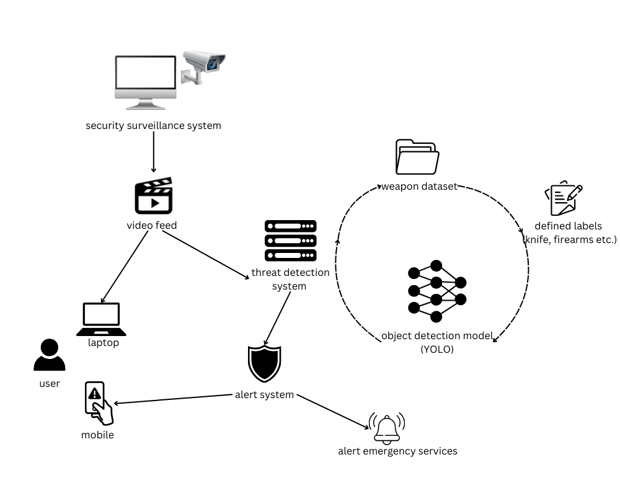
  - Data Composition

Our study required the creation of a specialized dataset tailored for military and security applications. This dataset was meticulously curated to include a wide range of items commonly encountered in military or hostile environments, with the primary objective of distinguishing between threat and non-threat objects. Several types of threat objects, such as firearms, grenades, explosives, and other military-grade weapons, were specifically included to ensure accurate detection and classification in real-world combat and security scenarios.
To improve the reliability and validity of the model, we employed a multi-source, cross-sectional data collection strategy. To have a fair amount of data, we gathered image sets from various reliable datasets and platforms like Roboflow, Kaggle, and Open Images Dataset. This diversified data-sourcing approach had several objectives as outlined below. Primarily, it facilitated the acquisition of a large set of images of various object types, in different conditions and locations. Secondly, it reduces the amount of bias that may arise through the use of a single source of information. It allowed us to incorporate a wide range of object images belonging to different training datasets to cover a wider range of variations in the object appearance, illumination, and viewpoint.
The multi-source approach also significantly enhanced the model's ability to perform well across a wide range of real-world scenarios. The environments can vary greatly in terms of layout, lighting, and clutter, and our diverse dataset helps ensure that the model can generalize effectively to these varied conditions. Moreover, by including a mix of professional and user-generated content from different sources, we aimed to bridge the gap between controlled, high-quality images and the often imperfect, real-world captures that a security system might encounter.
To address issues regarding data variety, we utilized augmentation techniques like flips, rotations, and changes in brightness and contrast. Furthermore, we employed generative models such as GANs to synthesize additional samples that closely resemble real-life military and hostile scenarios, particularly involving threat objects. Noting that in the training sets some classes, such as threat objects (e.g., firearms and explosives), were represented less frequently than others, we used SMOTE to create artificial samples for the underrepresented class, increasing its density without duplicating similar samples. To ensure compliance with privacy regulations while maintaining data utility, we applied data masking and scrubbing techniques to eliminate any personally identifiable information (PII).
In total, our custom dataset comprised:
- 21,482 images: 18855 for training, 1749 for validation, and 878 for testing.
- 14,152 annotations
- 6 classes: knife, ammo, firearm, grenade, pistol, and rocket.
- Preprocessing: auto-oriented and stretched to 640x640 pixels.
- Augmentation:
- flip (horizontal and vertical)
- rotate (90 degrees, clockwise, counter-clockwise, upside-down)
- rotation (b/w -15 to 15 degrees)
- grayscale to 20% images
- hue (b/w -15 to 15 degrees)
- saturation (b/w -25 to 25 degrees)
- brightness (b/w -15 to 15 degrees)
- exposure (b/w -15 to 15 degrees)
- noise up to 1.96% of pixels
Fig. 2. Samples of annotated data from the dataset 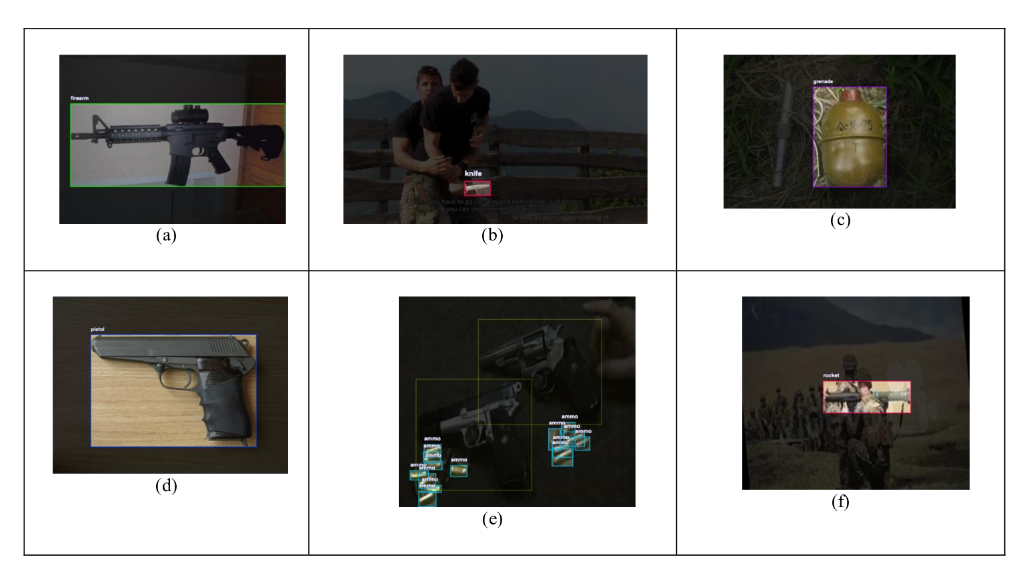

Due to the insufficient representation of the ammo class in the dataset, we made a deliberate decision to exclude it from the training and validation processes. This strategic choice was made to prevent potential model bias and unreliable performance metrics that could result from an underrepresented class.
  - Model Selection
Considering the tradeoffs between various object detection algorithms, we selected YOLO (You Only Look Once) as the major algorithm for our study particularly because of its single-stage architecture, fast real-time efficiency, and high accuracy. In generalizability, YOLO has high robustness so that even when it’s implemented in a new and unfamiliar scenario, it is not likely to fail. Unlike previous approaches that repurpose classifiers for detection, YOLO is a versatile detector that learns to detect various objects. It acquires generalized representations of objects, enabling it to surpass leading detection methods like the Deformable Parts Model (DPM) and Region-based Convolutional Neural Network (R-CNN) by a good margin.
YOLO's architecture consists of three main components:
- Backbone: A convolutional neural network (CNN) that serves as the feature extractor. It processes the input image to extract high-level features. YOLOv8 employs an advanced backbone, improving upon previous iterations.
- Neck: Intermediate layers that refine and aggregate features from the backbone. These layers enhance object detection performance by creating a feature pyramid network (FPN) or similar structures.
- Head: The output layer responsible for generating predictions. YOLOv8 incorporates an anchor-free split Ultralytics head, which predicts bounding boxes, object classes, and confidence scores directly.
YOLO provides specialized models for different computer vision tasks:
- YOLO (standard): Object Detection
- YOLO-seg: Instance Segmentation
- YOLO-pose: Pose Estimation and Key point Detection
- YOLO-obb: Oriented Bounding Box Detection
- YOLO-cls: Image Classification
For our study, we focus on the standard YOLO model for object detection only.
The YOLO object detection architecture divides the input image into an S × S grid. For each grid cell, it predicts B bounding boxes, confidence scores for those boxes, and C class probabilities. These predictions are encoded as an S × S × (B * 5 + C) tensor.
- Bounding Box Prediction:
$$b_{x}=σ\left(t_{x}\right)+c_{x}$$
$$b_{y}=σ\left(t_{y}\right)+c_{y}$$
$$b_{w}=p_{w}e^{t_{w}}$$
$$b_{h}=p_{h}e^{t_{h}}$$

Where $\left(b_{x},b_{y},b_{w},b_{h}\right)$ are the predicted box coordinates, $\left(t_{x},t_{y},t_{w},t_{h}\right)$ are the network outputs, $\left(c_{x},c_{y}\right)$ are the top-left coordinates of the grid cell, and $\left(p_{w},p_{h}\right)$ are anchor box dimensions.
- Objectness Score:
$$Pr\left(Object\right)*IOU_{pred}^{truth}=σ\left(t_{o}\right)$$
YOLO also offers multiple scaled versions to balance performance and computational requirements:
- nano: Smallest and fastest, suitable for resource-constrained devices.
- small: Balances speed and accuracy for general applications.
- medium: Improved accuracy with moderate computational demands.
- large: High accuracy for more complex scenarios.
- extra-large: Highest accuracy, ideal for applications prioritizing detection performance over speed.
The study compares all the versions offered in terms of speed and accuracy.
There have also been multiple iterations in the YOLO family. Each iteration has its own set of improvements and optimizations:
- YOLOv8 (Ultralytics, 2023):
  - Introduces a new architecture with improved backbone and neck for better feature extraction and aggregation.
  - Incorporates an anchor-free split Ultralytics head for bounding box and class predictions.
- YOLOv9 (Early 2024):
  - An experimental model trained on the Ultralytics YOLOv5 codebase.
  - Introduces Programmable Gradient Information, allowing the model to learn and utilize richer gradient information during training.
  - Implements an explicit feature pyramid, potentially enhancing detection across various scales.
- YOLOv10 (Tsinghua University, 2024):
  - Eliminates the need for Non-Maximum Suppression through consistent dual assignments.
  - Features a holistic efficiency-accuracy-driven design, optimizing the architecture for both speed and accuracy.
  - Employs novel feature extraction techniques, potentially leading to better performance in complex scenes.
- YOLO11 (Ultralytics, 2024):
  - Latest iteration in the YOLO series by Ultralytics.
  - Improved backbone and neck architecture for enhanced feature extraction.
  - Refined architectural designs and optimized training pipelines for faster processing speeds.
The iterations before YOLOv8, such as YOLOv5 and YOLOv6, have also contributed to the evolution of the single-shot detection architecture, but YOLO11 is the latest and most advance version introduced, thus making it the focus of our study.
  - Model Training

Fine-tuning Process. The fine-tuning process involved:
- Epoch Selection: Ultralytics recommends 300 epochs as a general starting point for training YOLO models.
- Image size: Experimented with different image resolutions to balance detection accuracy and processing speed, settling on 640x640 pixels.
- Learning rate: Utilized learning rate schedules and adaptive learning rate algorithms to optimize model convergence.
- Batch size: Adjusted batch sizes to maximize GPU utilization and training efficiency. Ultimately, we settled on a batch size of 16 for optimal performance.

Post-processing: Non-Maximum Suppression (NMS). We applied Non-Maximum Suppression (NMS) as a post-processing step to optimize detection accuracy and reduce false positives. YOLOv10, by design, does not require NMS due to its consistent dual assignments approach. NMS works by:
- Selecting bounding boxes with confidence scores above a predefined threshold.
- Identifying the box with the highest confidence score for each detected object.
- Suppressing overlapping boxes that exceed a specified Intersection over Union (IoU) threshold.
NMS score for box i:
$s_{i}=\max_{j≠i}IoU\left(b_{i},b_{j}\right)⋅c_{i}$
Where $b_{i}$ and $b_{j}$ are bounding boxes, and $c_{i}$ is the confidence score for box i.
By retaining only the highest-scoring boxes, NMS effectively reduces redundant detections while preserving distinct object instances.
  - Model Evaluation
To comprehensively assess the performance of our fine-tuned YOLO models, we employed a suite of standard evaluation metrics:

Mean Average Precision (mAP). mAP calculates the average precision across all object classes and various IoU thresholds, providing a holistic measure of the model's detection capabilities across different object types and confidence levels.
$$mAP=\frac{1}{n}\sum_{i=1}^{n}{A}P_{i}$$
where:
    - $n$ is the number of classes
    - $AP_{i}$ is the Average Precision for class $i$

Intersection over Union (IoU). IoU quantifies the overlap between predicted and ground truth bounding boxes, indicating the model’s localization accuracy.
$$IoU=\frac{AreaofOverlap}{AreaofUnion}$$
The model has different mAPs for different IoU thresholds:
    - $mAP@0.5$: IoU threshold of 0.5
    - $mAP@0.5:0.95$: mAP calculated over IoU thresholds from 0.5 to 0.95
    - $mAP@0.75$: IoU threshold of 0.75

F1 Score. The harmonic mean of precision and recall, balancing the model’s ability to correctly identify objects (precision) with its ability to find all relevant objects (recall).
$$F1=2×\frac{Precision×Recall}{Precision+Recall}$$

Precision and Recall. The ratio of correctly predicted positive observations to the total predicted positive observations and all actual positive observations.
$$Precision=\frac{TP}{TP+FP}$$
$$Recall=\frac{TP}{TP+FN}$$
where:
    - $TP$ is the number of true positives
    - $FP$ is the number of false positives
- Results and Discussion
  - Model Performance Comparison
The following table summarizes the performance of all the different YOLO11 variants on the constructed test dataset. The inference time was calculated by averaging 100 inference times recorded on the same image randomly picked in the test dataset.
Table 2. Comprehensive comparison of different YOLO11 variants
Model Variant | mAP@0.5 | mAP@0.5:0.95 | Precision | Recall | Inference Time (ms)
YOLO11n | 0.867 | 0.666 | 0.885 | 0.815 | 68.46
YOLO11s | 0.885 | 0.700 | 0.911 | 0.818 | 123.18
YOLO11m | 0.897 | 0.727 | 0.931 | 0.822 | 243.71
YOLO11l | 0.899 | 0.739 | 0.926 | 0.840 | 328.03
YOLO11x | 0.895 | 0.740 | 0.933 | 0.824 | 514.49
Fig. 3. Precision v/s Epoch graph for all YOLO11 variants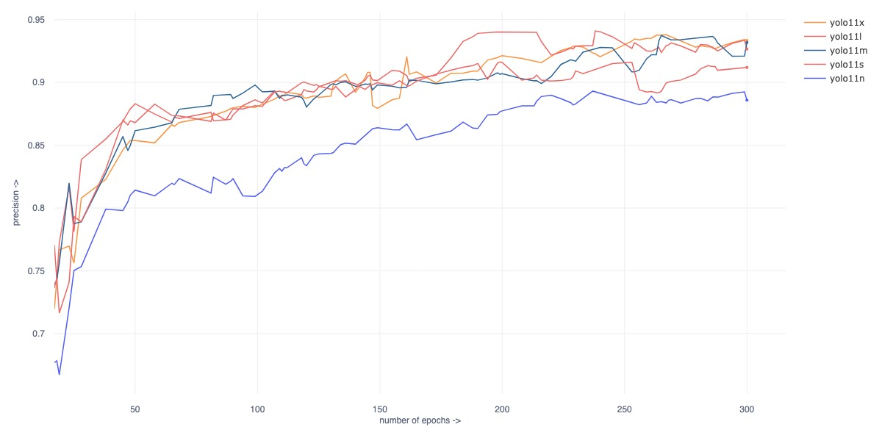
It's evident that the model size correlates positively with detection accuracy, but at the cost of increased inference time. The YOLO11x model demonstrates the best overall performance among all variants, with the highest mAP, precision, and recall scores, but only by a very small margin, with the “x” model scoring precision of 0.9334 and the “m” scoring precision of 0.9319. Also, the improved accuracy of YOLO11x comes at a significant computational cost, scoring the longest inference time among all variants. This makes YOLO11-xl less suitable for real-time detection scenarios where low latency is crucial. In contrast, the YOLO11-nano variant, despite having the lowest accuracy scores, boasts the fastest inference time at 68.46ms, making it more appropriate for applications that prioritize speed over maximum accuracy.
After a careful analysis of the trade-off between performance and speed reveals that YOLO11-medium (YOLO11m) emerges as the best overall choice for many practical applications.
  - Confusion Matrix Analysis
The confusion matrix provides a detailed breakdown of correct predictions and misclassifications for each class, including a "background" representing instances where the model determined no object was present in the image. It's important to note that the ammo class was deliberately excluded from the model's training and evaluation due to insufficient representation in the dataset.
Fig. 4. Confusion matrix generated by YOLO11m (% by row)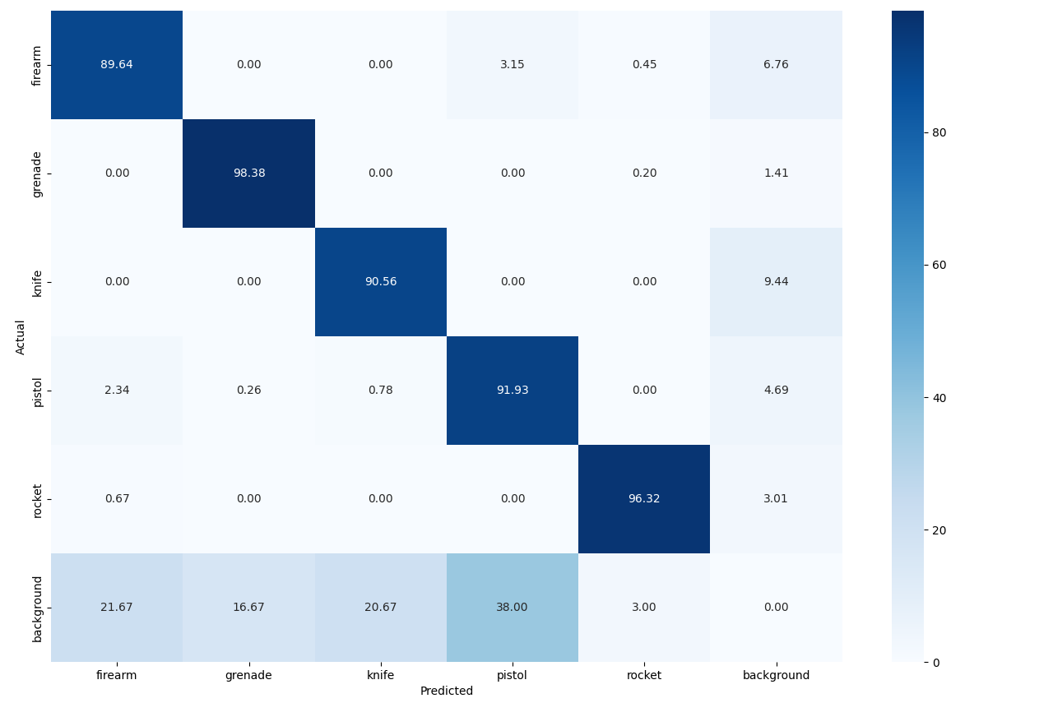
  - Non-Maximum Suppression (NMS) Analysis
We applied non-maximum suppression on the trained YOLO11m model at different Intersection over Union (IoU) thresholds to determine the optimal IoU threshold:

Table 3. Impact of NMS IoU threshold on various metrics (YOLO11m model)
NMS IoU Threshold | mAP@0.5 | mAP@0.5:0.95 | Precision | Recall | F1 Score
base | 0.868 | 0.710 | 0.934 | 0.789 | 0.856
0.1 | 0.884 | 0.720 | 0.931 | 0.815 | 0.869
0.2 | 0.891 | 0.724 | 0.930 | 0.822 | 0.873
0.3 | 0.896 | 0.727 | 0.929 | 0.829 | 0.876
0.4 | 0.900 | 0.729 | 0.925 | 0.832 | 0.876
0.5 | 0.902 | 0.730 | 0.929 | 0.830 | 0.877
0.6 | 0.901 | 0.730 | 0.918 | 0.838 | 0.876
0.7 | 0.897 | 0.727 | 0.933 | 0.822 | 0.874
0.8 | 0.889 | 0.722 | 0.932 | 0.814 | 0.869
0.9 | 0.856 | 0.701 | 0.871 | 0.799 | 0.833
Analysis of the results reveals that most performance metrics demonstrate monotonic improvement as the IoU threshold increases up to 0.5, followed by a gradual decline. Specifically, mAP@0.5 increases from 0.868 to 0.902, while mAP@0.5:0.95 improves from 0.710 to 0.730. The F1 score, which balances precision and recall, reaches its peak of 0.877 at an IoU threshold of 0.5. While precision shows some fluctuation across different thresholds, ranging from 0.918 to 0.934, recall exhibits a clear peak of 0.838 at an IoU threshold of 0.6. Based on these comprehensive results, we determined that an IoU threshold of 0.5 provides optimal overall performance for NMS in our implementation, maximizing the balance between precision and recall while maintaining strong mAP value.
Fig. 5. Impact on performance of YOLO11m on varying NMS IoU Thresholds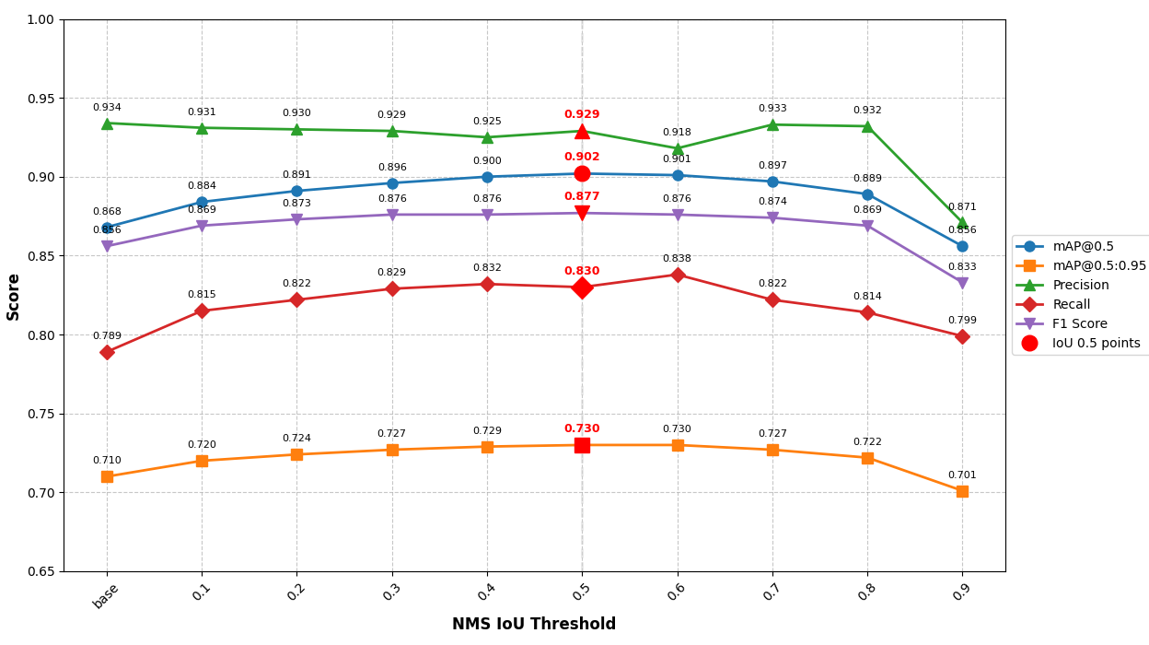
  - Comparison of proposed solution with model with others
Table 4. Comparison of proposed solution with existing deep learning solutions
Paper | Technique used | mAP@0.5 (%)
Dalal et al. [21] | YOLOv7 with transfer learning & Quantization | 81.90
Hashmi et al. [22] | YOLOv3  YOLOv4 | 77.30  84.85
Olmos et al. [25] | Faster R-CNN | 84.21
Tiwari et al. [23] | Harris interest point detector | 84.26
Carrobles et al. [24] | Faster R-CNN | 85.44
Proposed | YOLO11m  YOLO11m + NMS | 89.72  90.29
The proposed YOLO11m with NMS achieves state-of-the-art performance with a mAP@0.5 of 90.29%, outperforming previous approaches including YOLOv7 with transfer learning (81.90%), YOLOv4 (84.85%), and Faster R-CNN implementations (84.21-85.44%). This significant improvement of 4.85% over the closest competing method demonstrates the effectiveness of our approach in object detection tasks.

Conclusion
This study demonstrates the effectiveness of AI-powered surveillance systems using the YOLO object detection framework, particularly the YOLO11 architecture. Through comprehensive testing of different model variants, we found that YOLO11-medium (YOLO11m) offers the optimal balance between detection accuracy and computational efficiency, achieving an mAP@0.5 of 89.7% while maintaining practical inference times. The implementation of Non-Maximum Suppression with an IoU threshold of 0.5 further improved the model's performance to 90.53% mAP@0.5, surpassing existing solutions in the field by approximately 5-13 percentage points. These results suggest that AI-enhanced surveillance systems can significantly improve threat detection capabilities while maintaining real-time processing requirements. However, future work should address the current limitations in detecting smaller objects like ammunition and explore ways to reduce computational overhead for more resource-constrained deployments. The success of this implementation provides a promising foundation for the development of more sophisticated and reliable AI-powered security systems.

References
- Kale, Priti Vasant, and Samidha Dwivedi Sharma. "A review of securing home using video surveillance." Int. J. Sci. Res 3.5 (2014): 1150-1154.
- Ko, T. (2008). A survey on behavior analysis in video surveillance for homeland security applications. 2008 37th IEEE Applied Imagery Pattern Recognition Workshop. doi:10.1109/aipr.2008.4906450.
- Elharrouss, Omar, Noor Almaadeed, and Somaya Al-Maadeed. "A review of video surveillance systems." Journal of Visual Communication and Image Representation 77 (2021): 103116.
- Diwan, T., Anirudh, G. & Tembhurne, J.V. Object detection using YOLO: challenges, architectural successors, datasets and applications. Multimed Tools Appl 82, 9243–9275 (2023).
- Redmon, Joseph, et al. "You only look once: Unified, real-time object detection." Proceedings of the IEEE conference on computer vision and pattern recognition. 2016.
- M. G. Ragab et al., "A Comprehensive Systematic Review of YOLO for Medical Object Detection (2018 to 2023)," in IEEE Access, vol. 12, pp. 57815-57836, 2024, doi: 10.1109/ACCESS.2024.3386826.
- Yang, S., Wang, Y., Guo, S., Feng, S.: An operation site security detection method based on point cloud data and improved YOLO algorithm under the architecture of the power internet of things. J. Eng. 2024, e12344 (2024).
- Wu, Wennan & Lai, Jizhou. (2024). Multi Camera Localization Handover Based on YOLO Object Detection Algorithm in Complex Environments. IEEE Access. PP. 1-1. 10.1109/ACCESS.2024.3357519.
- Rezaee, K., Rezakhani, S.M., Khosravi, M.R. et al. A survey on deep learning-based real-time crowd anomaly detection for secure distributed video surveillance. Pers Ubiquit Comput 28, 135–151 (2024).
- Yadav, S.P., Jindal, M., Rani, P. et al. An improved deep learning-based optimal object detection system from images. Multimed Tools Appl 83, 30045–30072 (2024).
- Maruf, Md Omar Faruk & Islam, Md. Riadul & Rafi, Md. Jubayar & Shake, Abu & Islam, Tariqul. (2024). Non-permissible Mobile Detection to Enhance Security in Bangladeshi Museum: A Multiprocess YOLO-Based Approach. 10.1109/ICEEICT62016.2024.10534325.
- Cong, Xiaohan & Li, Shixin & Chen, Fankai & Liu, Chen & Meng, Yue. (2023). A Review of YOLO Object Detection Algorithms based on Deep Learning. Frontiers in Computing and Intelligent Systems. 4. 17-20. 10.54097/fcis.v4i2.9730.
- Sarimole, Frencis & Septianto, Ahas. (2024). Implementation of IoT-Based Facial Recognition for Home Security System Using Raspberry Pi and Mobile Application. International Journal Software Engineering and Computer Science (IJSECS). 4. 453-462. 10.35870/ijsecs.v4i2.2554.
- Zhao J, Xu Y, Zhu W, Liu M, Zhao J. Real-Time Early Safety Warning for Personnel Intrusion Behavior on Construction Sites Using a CNN Model. Buildings. 2023; 13(9):2206.
- Jeon Dong-Hyeon, Kim Tae-Sung, Kim Jin-Sung. A Method for Reducing False Negative Rate in Non-Maximum Suppression of YOLO Using Bounding Box Density. J Multimed Inf Syst 2023;10(4):293-300.
- T. M. Pandit, P. M. Jadhav and A. C. Phadke, "Suspicious object detection in surveillance videos for security applications," 2016 International Conference on Inventive Computation Technologies (ICICT), Coimbatore, India, 2016, pp. 1-5, doi: 10.1109/INVENTIVE.2016.7823224.
- Dedeoglu, Y. (2004). Moving object detection, tracking and classification for smart video surveillance.
- C. R. del-Blanco, F. Jaureguizar and N. Garcia, "An efficient multiple object detection and tracking framework for automatic counting and video surveillance applications," in IEEE Transactions on Consumer Electronics, vol. 58, no. 3, pp. 857-862, August 2012, doi: 10.1109/TCE.2012.6311328.
- Burton, A. M., Wilson, S., Cowan, M., & Bruce, V. (1999). Face Recognition in Poor-Quality Video: Evidence From Security Surveillance. Psychological Science, 10(3), 243–248. doi:10.1111/1467-9280.00144.
- S. Al-Azani and E. -S. M. El-Alfy, "Enhanced Video Analytics for Sentiment Analysis Based on Fusing Textual, Auditory and Visual Information," in IEEE Access, vol. 8, pp. 136843-136857, 2020, doi: 10.1109/ACCESS.2020.3011977.
- Dalal S, Lilhore UK, Sharma N, Arora S, Simaiya S, Ayadi M, Almujally NA, Ksibi A. 2024. Improving smart home surveillance through YOLO model with transfer learning and quantization for enhanced accuracy and efficiency. PeerJ Computer Science 10:e1939
- T. S. S. Hashmi, N. U. Haq, M. M. Fraz and M. Shahzad, "Application of Deep Learning for Weapons Detection in Surveillance Videos," 2021 International Conference on Digital Futures and Transformative Technologies (ICoDT2), Islamabad, Pakistan, 2021, pp. 1-6, doi: 10.1109/ICoDT252288.2021.9441523.
- Rohit Kumar Tiwari, Gyanendra K. Verma, A Computer Vision based Framework for Visual Gun Detection Using Harris Interest Point Detector, Procedia Computer Science, Volume 54, 2015, Pages 703-712, ISSN 1877-0509, https://doi.org/10.1016/j.procs.2015.06.083.
- Fernandez-Carrobles, M.M., Deniz, O., Maroto, F. (2019). Gun and Knife Detection Based on Faster R-CNN for Video Surveillance. In: Morales, A., Fierrez, J., Sánchez, J., Ribeiro, B. (eds) Pattern Recognition and Image Analysis. IbPRIA 2019. Lecture Notes in Computer Science(), vol 11868. Springer, Cham. https://doi.org/10.1007/978-3-030-31321-0_38
- Olmos, R., Tabik, S., & Herrera, F. (2018). Automatic handgun detection alarm in videos using deep learning. Neurocomputing, 275, 66–72. doi:10.1016/j.neucom.2017.05.0

